 | 
COUNCIL ASSESSMENT REPORT
NORTHERN REGIONAL PLANNING PANEL

PANEL REFERENCE & DA NUMBER | PPSNTH-410 – DA2025 - 97.1
PROPOSAL | Staged 115 Lot Residential Subdivision and Associated Infrastructure, and 1 dwelling (proposed Lot 56)
ADDRESS | Lot 33 DP 754405, 169B Ocean Drive, Kew
APPLICANT | Hopkins Consultants Pty Ltd
OWNER | Jojeni Investments Pty Ltd
DA LODGEMENT DATE | 25 February 2025
APPLICATION TYPE | Development Application (Designated and Integrated)
REGIONALLY SIGNIFICANT CRITERIA | Section 2.19(1) and Clause 8(b) of Schedule 6 of State Environmental Planning Policy (Planning Systems) 2021 declares the proposal regionally significant development as the proposal is for coastal subdivision for more than 100 lots wholly or partly in a sensitive coastal location. The site is partly within mapped proximity area to coastal wetlands.
CIV | $12.507M (excluding GST)
CLAUSE 4.6 REQUESTS | Nil
LIST OF ALL RELEVANT PLANNING CONTROLS (S4.15(1)(A) OF EP&A ACT) | - State Environmental Planning Policy (Biodiversity and Conservation) 2021  - State Environmental Planning Policy (Sustainable Buildings) 2022  - State Environmental Planning Policy (Planning Systems) 2021  - State Environmental Planning Policy (Primary Production) 2021  - State Environmental Planning Policy (Resilience and Hazards) 2021  - State Environmental Planning Policy (Transport and Infrastructure) 2021  - Port Macquarie-Hastings Local Local Environmental Plan 2011;  - Port Macquarie-Hastings Development Control Plan 2013.
AGENCY REFERRALS | - Essential Energy  - New South Wales Rural Fire Service (RFS)  - Department of Climate Change, Energy, the Environment and Water - Water Group  - Department of Planning, Housing and Infrastructure - Crown Lands and Public Spaces  - Department of Planning Housing and Infrastructure
TOTAL & UNIQUE SUBMISSIONS KEY ISSUES IN SUBMISSIONS | 1 submission received.  Key issues raised:  - Link roads and Area 15 Voluntary Planning Agreement - Link Roads A and B.  - Relationship to neighbouring approved subdivision DA2017 - 1059.
DOCUMENTS SUBMITTED FOR CONSIDERATION | - Subdivision plans  - Stockpile plans  - Dwelling plans on proposed Lot 56  - Vegetation Management Plan Ocean Drive, Kew (EPBC 2018/8296)  - Environmental Impact Statement - Version 3  - Traffic report - Version 7  - Bushfire report - Version 2  - Local Infrastructure Contributions advice - Botanic Drive  - Secretary’s Environmental Assessment Requirements (SEARs)  - Hones Lawyers Road link opinion
SPECIAL INFRASTRUCTURE CONTRIBUTIONS (S7.24) | N/A
RECOMMENDATION | Approval
DRAFT CONDITIONS TO APPLICANT | Yes
SCHEDULED MEETING DATE | 18 May 2026
PLAN VERSION | - Subdivision plans Revision N - dated 30 April 2026  - Lot 56 dwelling plans - dated 30 April 2026  - Stockpile plans Revision A - dated 15 August 2025  - Dwelling plans - dated 30 April 2026 and 17 April 2025
PREPARED BY | Pat Galbraith-Robertson
DATE OF REPORT | 4 May 2026

EXECUTIVE SUMMARY

The Development Application (DA2025-97.1) seeks consent for a staged residential subdivision and associated infrastructure, and construction of a dwelling (on proposed Lot 56).

Specifically, the proposal (as amended) involves:

- Earthworks to prepare the site for residential subdivision.
- 113 residential lots.
- 1 lot to be developed for future medium density development.
- 1 large master lot to be retained for future development.
- 1 lot to contain proposed stormwater infrastructure.
- Residue lot for remainder of C2 and C3 zoned land, to be retained by proponent for Vegetation Management Plan works.
- Construction of internal road network.
- Construction of pedestrian and cycle pathways to be linked to future network.
- Construct road drainage for entire road catchment.
- Construct internal water infrastructure and connect to existing 375mm water main on the southern side of Ocean Drive.
- Construct stormwater infrastructure and link to existing. 6 water quality basins and water treatment to be contained within drainage lot.
- Sewer infrastructure to each lot. Works in cooperation with Council to facilitate construction of sewer trunk main network to connect to existing sewer pump station.
- Construct electricity and communications infrastructure for each lot.
- Street trees and street lights through the site.
- Temporary Stockpiles of up to 80,000m3
- Dwelling on proposed Lot 56.

Several amendments have been made to the proposed subdivision and dwellings during assessment in response to key assessment issues raised. The amendments have included a reduction in the amount of lots originally proposed from 151 to 115 lots and changes to the design footprint and layout of the subdivision. All previous dwellings originally proposed have been deleted from the proposal with the exception of a single dwelling on proposed Lot 56. This dwelling has been modified in design to reflect bushfire requirements and lot reconfiguration.

The site comprises two areas of R1 general residential zoned land. C2 environmental conservation and C3 environmental management zone forms the southeast boundary and also bisects the site to separate the R1 zone at the northwest corner. The proposed residential lots are located within the residential zoned portion of the site.

Subdivision of the land is permissible with consent under clause 2.6 of the Port Macquarie-Hastings Local Environmental Plan 2011.

The application is Designated Development under State Environmental Planning Policy (Resilience and Hazards) and Integrated Development under the Rural Fires Act 1997 and Water Management Act.

General Terms of Approval (GTAs) have been received from the following agencies under the relevant legislation:

- NSW Rural Fire Service - Section 100B of the Rural Fires Act 1997 (as amended during assessment)
- Department of Climate Change, Energy, the Environment and Water - Water Group
- Section 91 of the Water Management Act 2000

Jurisdictional prerequisites to the grant of consent imposed by the following controls have been satisfied:

- Section 4.9 of the Biodiversity and Conservation SEPP requiring that Council’s determination of the application must consider whether the development is likely to have low or no impact on koalas or koala habitat;
- Section 2.1 of the Sustainable Buildings SEPP in regards to a BASIX certificate;
- Section 2.27 of the Primary Production SEPP for potential impact on oyster aquaculture;
- Sections 2.7 and 2.8 of the Resilience and Hazards SEPP identifying the development as designated and that the proposed development will not significantly impact on coastal wetlands;
- Section 4.6 of the Resilience and Hazards SEPP for consideration of whether the land is contaminated;
- Section 2.48(2) of the Transport and Infrastructure SEPP in relation to consultation for development in proximity to electricity infrastructure;
- Clause 2.3 of the LEP regarding permissibility and zone objectives.
- Clause 4.1 of the LEP regarding minimum lot size provisions.
- Clause 6.1 of the LEP regarding satisfactory arrangements for state public infrastructure.
- Clause 7.13 of the LEP and ensuring adequate arrangements for the provision of essential services for the development.

The application including original development plans and documentation was placed on public exhibition from 6 March to 4 April 2025. 1 submission was received.

The application is referred to the Northern Planning Panel (‘the Panel’) as the development is ‘regionally significant development’, pursuant to Section 2.19(1) and Clause 8(b) of Schedule 6 of State Environmental Planning Policy (Planning Systems) 2021 as the proposal is for coastal subdivision for more than 100 lots wholly or partly in a sensitive coastal location (i.e. partly within mapped proximity area to coastal wetland).

A briefing was held with the Panel on 23 April 2025 where the following issues were identified and further clarity sought:

- Arrangements for public road access to the subdivision and consideration of impacts.
- Owner’s consent from Crown Lands.
- Bushfire Safety access arrangements.
- Address whether existing dwelling to be retained.
- Water and sewer servicing capacity.
- Impacts on mapped coastal wetlands.
- Flooding risk management.
- Amended traffic assessment.
- Potential yield identified with future subdivision lot and potential impact on road access.
- State Infrastructure Contribution levy contributions applicability.
- 1 submission received - issues to be addressed with link roads and VPA.

Having considered the planning controls and the proposal in detail (as amended), the following key issues are relevant to the assessment of this application:

- Arrangements for public road access to the subdivision and consideration of impacts.
- Crown Lands transfer arrangements.
- Bushfire Safety access arrangements.
- Water and sewer servicing capacity and arrangements.
- Impacts on mapped coastal wetlands.
- Bushfire Safety Authority requirements from New South Wales Rural Fire Service (RFS).
- General Terms of Approval requirements from Department of Climate Change, Energy, the Environment and Water - Water Group.
- Flooding risk management.
- Traffic impacts.
- Potential yield identified with future subdivision lot and potential impact on road access.
- State Infrastructure Contribution levy contributions applicability.
- 1 submission received - issues to be addressed with link roads and VPA.

Key issues are discussed in Section 5 of this report and have been addressed through amendments to the design, submission of additional information and specialist reports, and/or the recommended conditions of consent.

Having considered the matters under Section 4.15(1) of the EP&A Act, the site is considered suitable for the proposed development and the proposal adequately addresses relevant planning controls. The development is not considered to be contrary to the public's interest and will not result a significant adverse social, environmental or economic impact.

Following a detailed assessment of the proposal, pursuant to Section 4.16(1)(b) of the EP&A Act, DA2025 - 97.1 is recommended for approval subject to the conditions contained in Attachment A of this report.

- THE SITE AND LOCALITY

  - The Site

- The site has an area of 37 hectares and is regular in shape with a width of approximately 620m and a depth of 600m.
- The site has a crown road reserve running along the western edge of the site and partly along the southern edge.
- Access to the site is currently via a Crown Road connecting to Ocean Drive to the south which is understood to have been recently transferred to Council ownership.
- There is an existing single house and sheds in the middle of the site.
- The site is within a planned urban release area known as Area 15 Camden Haven Urban Release Area.
- The site has varied topography with a moderate slope in the north-western corner to gentle to flat slopes in the remainder. The highest point on the site is approximately 19.5m RL AHD and the lowest point is approximately 1.5m RL AHD.
- Existing powerlines traverse the site.
- The site is located approximately 35 kilometres south of Port Macquarie between Lakewood and Kew.
- The site subject to mapped bushfire risk, part acid sulfate soils and flooding.
- The site has been subject to vegetation clearing commenced under previous approved DA2017 - 394.
- The Structure Planning for this Urban Release Area is shown below with an extract from Development Control Plan 2013 (section D10.2:Area 15 Camden Haven):

Figure 1: Structure Plan Area 15
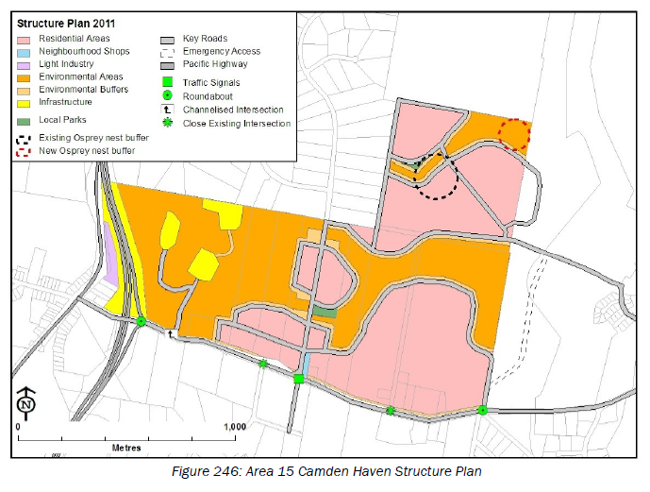
- There is an existing right of way easement which connects to the site from Botanic Drive to the east. See extract of Deposited Plan DP1250178 below:

Figure 2: Deposited Plan extract:
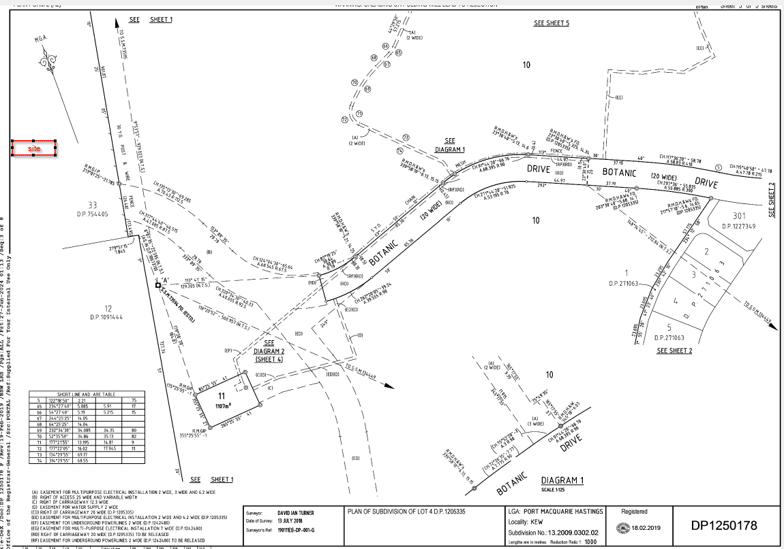
- Locality plan extracts are shown below to identify the site for the proposed development and immediate locality:

Figure 3 - Location map in North Coast Regional Environmental Plan 2041

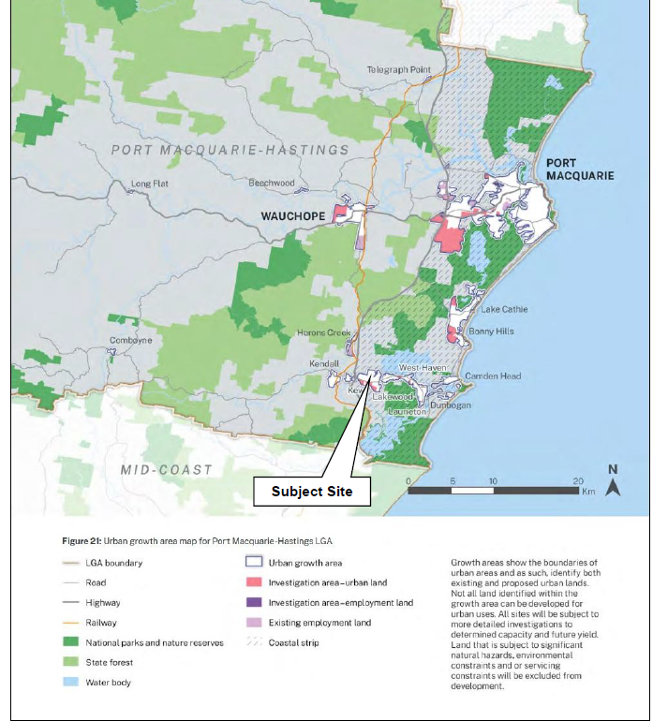

Figure 4 - Location Map

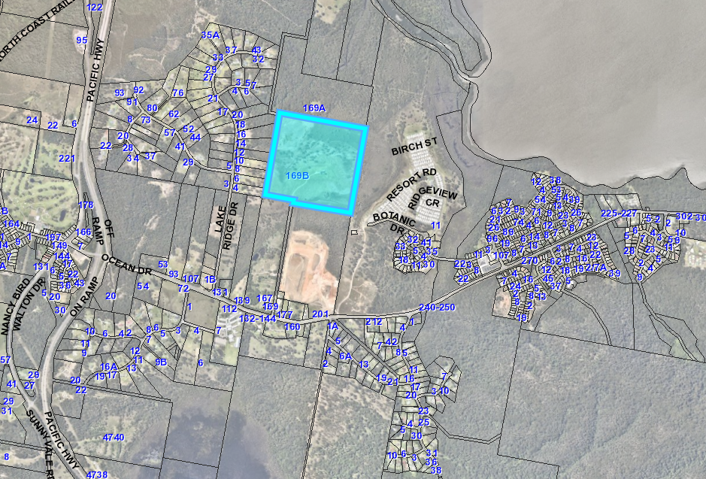

Figure 5 - Aerial Photograph of site with zoning line overlay

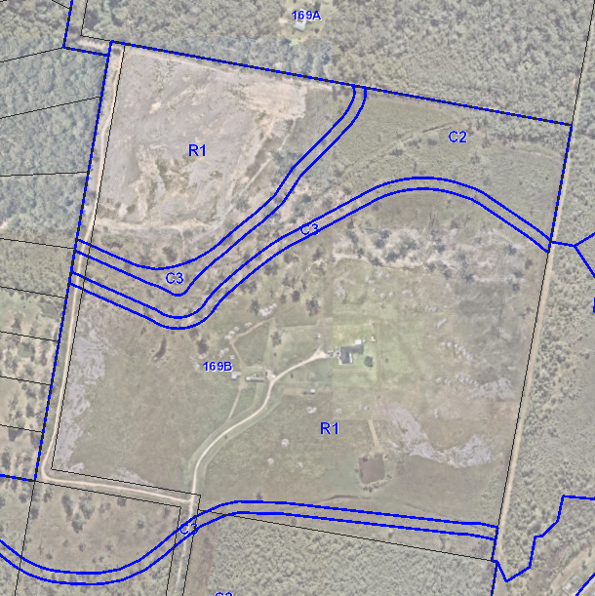

  - The Locality

- To the south of the site is land known as Woodlands South at 201 Ocean Drive, Kew. DA2023-73 is approved and under construction for residential subdivision and includes construction of a roundabout completed on Ocean Drive.
- The proposal relies upon primary road access from a western collector road approved under DA2017 - 1059 as shown on the proposed subdivision plans labelled ‘Future road connection to Lake Ridge Drive DA2017/1059’.
- To the west of the site is Lake Ridge Drive which contains a large lot residential subdivision of approximately 70 lots, with areas of dense vegetation and clearings containing dwellings. Lake Ridge Drive is accessed from Ocean Drive. The large lot residential subdivision extends further west towards the Pacific Highway.
- To the east of the site is mapped coastal wetlands and beyond is Laurieton Lifestyle Resort, an MHE currently accessed from the east via Botanic Drive, with approval to expand into the lot to the southeast of the site.
- To the north of the site is land zoned RU1 occupied with an existing dwelling which is heavily vegetated continuing further north to Heron’s Creek.
- To the north-west of the site is the Kew Kendall Sewerage Treatment Plant.
- The applicant has stated that the Area 15 roads strategy and Development Control Plan 2013 (DCP) provides for a fully funded road link west to Lake Ridge Drive, with the relevant road segments to be constructed by the respective landowners. The DCP also provides for a collector road link from the southeast corner of Woodlands North to Botanic Drive to be constructed and fully funded by Council, with no provision made in the Voluntary Planning Agreement (VPA) for its funding. The submitted plans are stated to provide for a connection from the site to Botanic Drive.

- THE PROPOSAL AND BACKGROUND

  - The Proposal

The proposal seeks consent for staged residential subdivision and associated infrastructure, and construction of a dwelling on proposed Lot 56.

Specifically, the proposal involves:

- Earthworks to prepare the site for residential subdivision.
- 113 residential lots.
- 1 lot to be developed for future medium density development.
- 1 large master lot to be retained for future development.
- 1 lot to contain proposed stormwater infrastructure.
- Residue lot for remainder of C2 and C3 zoned land, to be retained by proponent for Vegetation Management Plan works.
- Construction of internal road network.
- Construction of pedestrian and cycle pathways to be linked to future network.
- Construct road drainage for entire road catchment.
- Construct internal water infrastructure and connect to existing 375mm water main on the southern side of Ocean Drive.
- Construct stormwater infrastructure and link to existing. 6 water quality basins and water treatment to be contained within drainage lot.
- Sewer infrastructure to each lot. Works in cooperation with Council to facilitate construction of sewer trunk main network to connect to existing sewer pump station.
- Construct electricity and communications infrastructure for each lot.
- Street trees and street lights through the site.
- Temporary Stockpiles of upto 80,000m3.
- 1 dwelling on proposed Lot 56 after the lot is completed and registered.

Figure 6 - Extract of Site Plan

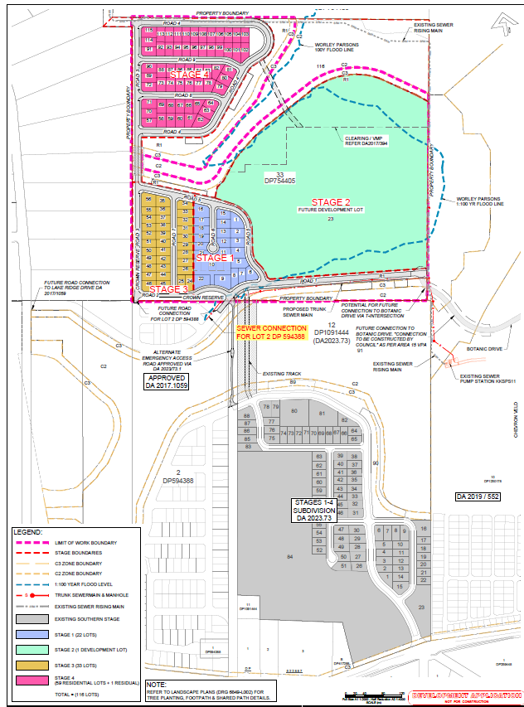

Figure 7 - Extract of site plan showing the single dwelling layout on proposed Lot 56

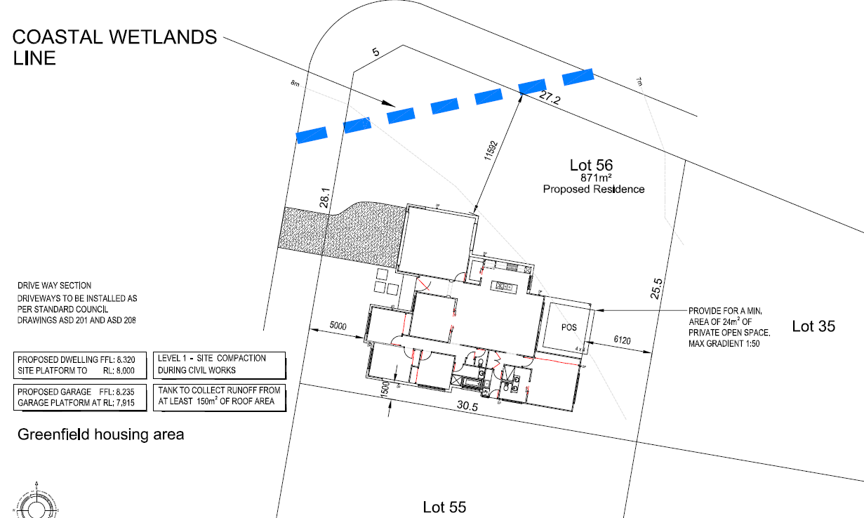

The key development data is provided in Table 1 below.

Table 1: Development Data
Control | Proposal
Site area | 29.2875 hectares not including Crown road reserves
Number of lots | 115 residential lots including 2 larger lots.
Lot sizes | All lots greater than 450m2
Clause 4.6 requests | Nil
Number of dwellings | 1 (as amended)
Landscaping | As shown on landscaping principles plan.
Setbacks for dwelling | As shown on site plan for dwelling lot No.56
Max height | 5.24m for dwelling lot No.56
Floor space ratio | <0.65:1 for dwelling lot No.56

Staging
Staging is proposed as follows:
Stockpile stage - Temporary stockpile prior to subdivision works certificate.
Stage One – 22 Torrens Title residential lots numbered from 1 to 22 (including the future development lot), road network and infrastructure to service Stage One.
Stage Two – Master lot numbered Lot 23 and infrastructure to service Stage Two.
Stage Three – 33 Torrens Title residential lots numbered 24 to 56, road network and infrastructure to service Stage Three.
Stage Four – 59 Torrens Title residential lots numbered 57 to 115, road network and infrastructure to service Stage Four.
Dwelling on proposed Lot 56 - Ability to construct when proposed Lot 56 complete/registered.

  - Background

The development application was lodged on 25 February 2025. A chronology of the assessment of Development Application since lodgement is outlined below including the Panel’s involvement with the application:

Table 2: Chronology of the DA
Date | Event
28 February 2025 | Referral to external agencies.
6 March 2025 | Exhibition of the application until 4 April 2025.
2 April 2025 | Initial assessment update provided to applicant.
3 April 2025 | Referral to Essential Energy.
3 April 2025 | Assessment update and RFI - Water and Sewer strategy, queries on stockpiles and details to address potential land contamination.
3 April 2025 | Applicant provided additional details to address stockpiles.
3 April 2025 | Applicant request to condition Water and Sewer strategy matters.
4 April 2025 | Essential Energy advice received.
4 April 2025 | Additional information request from DCCEE - Water.
10 April 2025 | Additional information request from RFS.
11 April 2025 | Site inspection.
14 April 2025 | Request for Information from Council to applicant.
15 April 2025 | DCCEE - Water follow up to applicant on RFI.
15 April 2025 | RFI made to applicant - copy of redacted submission, water strategy and owner’s consent.
15 April 2025 | Referral to DPHI for satisfactory arrangements certification.
17 April 2025 | Amended Traffic Impact Assessment received.
17 April 2025 | Response received to DCCEE - Water issues.
22 April 2025 | Advice sent to DCCEE - water that additional information received.
23 April 2025 | Panel briefing.
23 April 2025 | RFI to applicant on satisfactory arrangements certification.
28 April 2025 | Panel briefing notes sent to applicant for consideration.
12 May 2025 | Referral to Crown Lands.
13 May 2025 | Essential Energy advice sent to applicant for consideration.
13 May 2025 | Referral of additional information to DCCEE - water.
13 May 2025 | Additional information and amended plans received.
21 May 2025 | Referral of additional information to RFS.
23 May 2025 | Additional information request from DCCEE - water.
2 June 2025 | Update to submitter on assessment status.
2 June 2025 | RFI stormwater issues.
29 July 2025 | Bushfire Safety Authority issued including advice that Stage 4 not permitted until Botanic Drive eastern connection completed.
7 July 2025 | Follow up on status of RFIs to applicant.
31 July 2025 | Update to submitter on assessment status.
21 August 2025 | Additional information received.
10 September 2025 | RFI follow up on Botanic Drive connectivity, DCCEE-water, ecology, demolition clarification of existing dwelling, earthworks, retaining walls, stormwater, satisfactory arrangements certification, Crown road reserve detail and RFS.
19 September 2025 | Update from applicant with timing on all RFIs to be addressed.
25 September 2025 | Update from Crown Lands on review status.
26 September 2025 | Updated bushfire report and ecology addendum received.
29 September 2025 | Amended subdivision plans received.
8 October 2025 | Additional stormwater plan information received.
9 October 2025 | Further advice received from Crown Lands.
9 October 2025 | Satisfactory Arrangements Certification received from the DPHI.
17 October 2025 | Stormwater modelling detail received.
20 October 2025 | Updated Bushfire report received.
27 October 2025 | Referral of bushfire report back to RFS.
27 October 2025 | Update from Crown Lands.
27 October 2025 | Follow up on RFI status with applicant.
28 October 2025 | Amended subdivision plans received.
28 October 2025 | Referral of amendments back to DCCEE - water.
31 October 2025 | Advice to applicant that clause 37 revision H plans unable to be accepted.
5 November 2025 | Owner’s consent for Botanic Drive extension received from neighbour 11 Resort Road, Kew.
5 November 2025 | Assessment update provided to applicant with key issues outstanding.
7 November 2025 | Meeting with applicant to discuss assessment issues.
12 November 2025 | Advice from Crown Lands that acceptable to condition the part crown roads land transfer.
20 November 2025 | Further clarification provided to applicant on outstanding matters.
24 November 2025 | Follow up with DCCEE - water and RFS on review status of both referrals.
24 November 2025 | Advice received that DA2017 - 1059 for a neighbouring subdivision adjoining development site has been physically commenced.
25 November 2025 | Advice from RFS that proposal as amended unable to be supported.
25 November 2025 | Update from DCCEE - water.
28 November 2025 | Update to submitter on assessment status.
1 December 2025 | RFI - bushfire RFS, traffic, road connectivity, and DCCEE - water.
18 December 2025 | Amended plans Revision K received.
14 January 2026 | Temporary stockpiles added to DA.
15 January 2026 | Updated Essential Energy advice received.
15 January 2026 | RFS request for meeting to discuss assessment issues.
27 January 2026 | Meeting with RFS to discuss assessment issues.
27 January 2026 | Follow up with DCCEE - water.
28 January 2026 | Clause 37 amendment accepted for temporary stockpiles.
30 January 2026 | Follow up on water supply strategy.
2 February 2026 | RFI on offsets from DCCEE - water.
17 February 2026 | Additional information for DCCEE - water received.
17 February 2026 | Amended plans Revision L received
18 February 2026 | Additional information referred to DCCEE - water.
3 March 2026 | Revised Bushfire Safety Authority received from RFS.
5 March 2026 | Water supply strategy details received.
6 March 2026 | General Terms of Approval received from DCCEE - water.
24 March 2026 | RFI - Water supply arrangements alignment and road detail on plans relating to future Botanic Drive connection.
20 April 2026 | Amended plans Revision M received.
30 April 2026 | RFI - Draft conditions feedback sought and lot size issue for proposed Lot 56.
30 April 2026 | Amended house plan - site plan for proposed Lot 56 received.
1 May 2026 | Amended plans Revision N received - current plans.
1 May 2026 | Feedback received on draft conditions

  - Site History

- Consent was granted to DA2017 - 394 for vegetation removal on the site on 13 March 2019. The clearing plans were approved subject to the following:

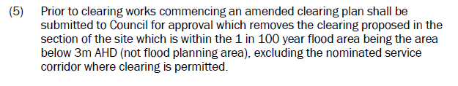
- A permit was issued for clearing of the site under the Commonwealth, Environment Protection and Biodiversity Act 1999 issued by the Department of Agriculture, Water and Environment (DAWE) dated 19 November 2020. Reference EPBC 2018/8296).
- On 20 September 2018, an Order was issued by the NSW Office of Environment and Heritage (OEH) pursuant to clause 34A(4) of the Biodiversity Conservation (Savings and Transitional) Regulation 2017. This essentially identifies that Part 7 of the Biodiversity Conservation Act 2016 doesn’t apply to the determination of a development application to which this clause applies but the former planning provisions apply instead:

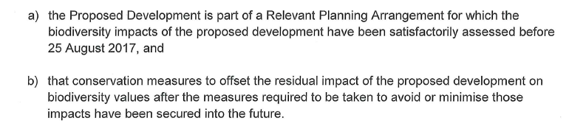
- A site-specific Vegetation Management Plan (VMP) was approved by DAWE. Council’s Ecologist considers that this VMP doesn’t satisfy the requirements of the Council and the current Planning Agreements in place.
- There is an existing Area 15 Planning Agreement in Place (VPA) (available on Council’s website titled Area 15 Planning Agreement - Gentlemore Pty Ltd, Haloville Pty Ltd, Somersby Rural Supplies Land Holdings Pty Ltd and Somersby Rural Supplies Pty Ltd). The VPA provides for the carrying out of works for local parks, roads, sewer and water supply works, dedication of specified land to Council, dedication of Environmental Offset Land, establishment, management and dedication of environmental lands & arrangements for payment of contributions.
- There is an existing right of way easement which connects to the site from Botanic Drive to the east.
- To the west of the site a neighbouring subdivision has been approved under DA2017 - 1059. This subdivision has been physically commenced during assessment of the application. The subdivision layout has been detailed on the amended subdivision plans.

- STATUTORY CONSIDERATIONS

When determining a Development Application, the consent authority must take into consideration the matters outlined in Section 4.15(1) of the Environmental Planning and Assessment Act 1979 (‘EP&A Act’). These matters as are of relevance to the development application include the following:

- the provisions of any environmental planning instrument, proposed instrument, development control plan, planning agreement and the regulations
(i) any environmental planning instrument, and
(ii) any proposed instrument that is or has been the subject of public consultation under this Act and that has been notified to the consent authority (unless the Planning Secretary has notified the consent authority that the making of the proposed instrument has been deferred indefinitely or has not been approved), and
(iii) any development control plan, and
(iiia) any planning agreement that has been entered into under section 7.4, or any draft planning agreement that a developer has offered to enter into under section 7.4, and
(iv) the regulations (to the extent that they prescribe matters for the purposes of this paragraph),
that apply to the land to which the development application relates,
- the likely impacts of that development, including environmental impacts on both the natural and built environments, and social and economic impacts in the locality,
- the suitability of the site for the development,
- any submissions made in accordance with this Act or the regulations,
- the public interest.

These matters are further considered below.

  - Environmental Planning Instruments, proposed instrument, development control plan, planning agreement and the regulations

The relevant environmental planning instruments, proposed instruments, development control plans, planning agreements and the matters for consideration under the Regulation are considered below.

- Section 4.15(1)(a)(i) - Provisions of Environmental Planning Instruments

The following Environmental Planning Instruments are relevant to this application:

- State Environmental Planning Policy (Biodiversity and Conservation) 2021
- State Environmental Planning Policy (Sustainable Buildings) 2022
- State Environmental Planning Policy (Housing) 2021
- State Environmental Planning Policy (Planning Systems) 2021
- State Environmental Planning Policy (Primary Production) 2021
- State Environmental Planning Policy (Resilience and Hazards) 2021
- State Environmental Planning Policy (Transport and Infrastructure) 2021
- Port Macquarie-Hastings Local Local Environmental Plan 2011

A summary of the key matters for consideration arising from these environmental planning instruments are outlined in Table 3 and considered in more detail below. Jurisdictional prerequisites to the grant of consent are shown in bold.

Table 3: Summary of Applicable Environmental Planning Instruments

EPI | Matters for Consideration  (Brief summary) | Comply (Y/N)
State Environmental Planning Policy (Biodiversity & Conservation) 2021 | Chapter 4: Koala Habitat Protection 2021 | Y
State Environmental Planning Policy (Planning Systems) 2021 | Chapter 2: State and Regional Development  - Section 2.19(1) declares the proposal regionally significant development pursuant to Clause 8 of Schedule 6. | Y
State Environmental Planning Policy (Sustainable Buildings) 2022 | Chapter 2: Standards for residential development - BASIX | Y
State Environmental Planning Policy (Primary Production) 2021 | Chapter 2: Primary Production and rural development  Division 4 - Consideration of effects of proposed development on oyster aquaculture. | Y
SEPP (Resilience & Hazards) | Chapter 2: Coastal Management  - Section 2.7(1)(d) - The application has been lodged as designated development due to the uncertainty surrounding whether subdivision not dividing mapped coastal wetlands is triggered or not.  - Section 2.8(1) - Development on land in proximity to coastal wetlands.  Chapter 4: Remediation of Land  - Section 4.6 - Potential contamination and remediation has been considered. | Y
State Environmental Planning Policy (Transport and Infrastructure) 2021 | Chapter 2: Infrastructure  - Section 2.48(2) (Determination of development applications—other development) – electricity transmission - the proposal is satisfactory subject to conditions. | Y
Proposed Instruments | None applicable. | N/A
Port Macquarie-Hastings Local Environmental Plan 2011 | - Clause 2.3 – Permissibility and zone objectives  - Clause 2.6 - Subdivision  - Clause 4.1 - Minimum subdivision lot size  - Clause 5.10 - Aboriginal heritage conservation  - Clause 5.21 - Flood planning  - Clause 6.1 - Satisfactory arrangements certification for State infrastructure  - Clause 6.2 - Arrangements for public infrastructure  - Clause 6.3 - Development Control Plan in place  - Clause 7.1 - Acid sulfate soils  - Clause 7.9 - Acoustic controls map  - Clause 7.13 - Essential services | Y

Detailed consideration of the relevant SEPPs and LEP is outlined below.

State Environmental Planning Policy (Biodiversity and Conservation) 2021

Chapter 4: Koala Habitat Protection 2021

Clause 4.4 - This SEPP applies to all non-rural zoned land within the Port Macquarie-Hastings Local Government Area.
Clause 4.9 - The property is over 1 hectare in size (including adjoining land in the same ownership) and does not have a Koala Plan of Management in place.
Before consent is granted, Council is required to assess whether the development is likely to have any impact on koalas or koala habitat. The following assessment comments are provided in this regard:

- The applicant has submitted details in an updated Environmental Impact Statement (EIS) which states that all vegetation has been cleared from the site under DAWE approval EPBC 2018/8296 dated 19 November 2020. Conditions were applied by DAWE to protect koalas. The applicant has stated that further consideration of Chapter 4 is not required and furthermore, no koalas have ever been recorded on the site.
- Council’s Ecologist has reviewed the proposal in regards to koala habitat impacts and the legislative requirements of this SEPP. For this development Section 4.9 (5b) of SEPP (Biodiversity Conservation) 2021 applies. Advice has provided that due to the development area being cleared already under a previous consent DA2017-394 - the proposal demonstrates no adverse impacts to koala habitat that the land subject to the development application. The proposal in particular does not include any trees proposed to be removed further than DA2017 - 394 with a diameter at breast height over bark of more than 10 centimetres.

Based on the above, consent to the development application on koala habitat grounds is supported and the proposal satisfies the requirements of this SEPP.
State Environmental Planning Policy (Planning Systems) 2021

Chapter 2: State and Regional Development

Section 2.19 states that development specified in Schedule 6 is regionally significant. The Northern Regional Planning Panel is the determining authority for regionally significant development. Schedule 6 Section 8 states:
“8 Coastal subdivision
(1) Development within the coastal zone for the purposes of subdivision of the following kind—
(a) subdivision of land for any purpose into more than 100 lots, if more than 100 of the lots will not be connected to an approved sewage treatment work or system,
(b) subdivision of land for residential purposes into more than 100 lots, if the land—
(i) is not in the metropolitan coastal zone, or
(ii) is wholly or partly in a sensitive coastal location”

There are 115 lots proposed. The land mapped as proximity to coastal wetlands is defined as being within the coastal zone and partly within a “sensitive coastal location”. The proposal is therefore regionally significant development.

The proposal is required to be determined by the Northern Regional Planning Panel.

State Environmental Planning Policy (Primary Production) 2021

Chapter 2 - Primary production and rural development
Pursuant to clause 2.27 and having regard to the location and nature of the proposed development and proposed stormwater controls the proposal will be unlikely to have any adverse impact on existing priority oyster aquaculture areas.
The proposal satisfies the requirements of this SEPP.
State Environmental Planning Policy (Sustainable Buildings) 2022

Chapter 2 - Standards for residential development - BASIX

A BASIX certificate has been submitted for the single dwelling on proposed Lot 56 demonstrating that the proposal will comply with the requirements of the SEPP. It is recommended that a condition be imposed to ensure that the commitments are incorporated into the development and certified at Occupation Certificate stage.

State Environmental Planning Policy (Resilience and Hazards) 2021

Clause 2.5 - This SEPP prevails over the Port Macquarie-Hastings LEP 2011 in the event of any inconsistency.
Chapter 2 - Coastal Management

Works are proposed within mapped coastal wetland areas. These works are identified as Designated Development and triggered the requirement to obtain SEARs and prepare an EIS. A Council Ecologist and DCCEE - Water have reviewed the proposal during assessment.

Clause 2.7(4) of the Coastal SEPP states:

A consent authority must not grant consent for development referred to in subclause (1) unless the consent authority is satisfied that sufficient measures have been, or will be, taken to protect, and where possible enhance, the biophysical, hydrological and ecological integrity of the coastal wetland or littoral rainforest.
Section 2.8(1) of the Coastal SEPP states that:
Development consent must not be granted to development on land identified as “proximity area for coastal wetlands” or “proximity area for littoral rainforest” on the Coastal Wetlands and Littoral Rainforests Area Map unless the consent authority is satisfied that the proposed development will not significantly impact on:
- the biophysical, hydrological or ecological integrity of the adjacent coastal wetland or littoral rainforest, or
- the quantity and quality of surface and ground water flows to and from the adjacent coastal wetland or littoral rainforest.
Having regard to Clause 2.7 - Development on certain land within coastal wetlands and littoral rainforest area the following assessment comments are provided:

- The site is partially mapped under SEPP Resilience and Hazards as both coastal wetlands and land in proximity to coastal wetlands as shown in Figure 5 below.
- The works affected by coastal wetlands mapping under the SEPP (Resilience and Hazards) 2021 is shown in blue in Figure 6, 7 and 8 below.
- The applicant has obtained Secretary’s Environmental Assessment Requirements (SEARS) prior to lodgement of the DA. The applicant has submitted details to address these requirements.
- The proposal includes both earthworks as per clause 2.7(1)(c)(i) and other development under clause 2.7(1)(d) including construction of roads and other infrastructure and subdivision. The location of the road crossing from Woodlands South to North was approved by Department of Agriculture Water and Environment (DAWE) for clearing for the service road. No additional clearing is required or proposed.
- The applicant makes reference to prior to the application of this mapping, the subject land was not mapped as coastal wetlands under SEPP 14 Wetlands (it’s immediate predecessor).
- Section 2.7(2) of the Coastal SEPP states that any works including earthworks and native vegetation removal within land identified as coastal wetlands is designated development. The proposed works in the coastal wetlands area are for a water quality basin, roads, stormwater, sewer and water infrastructure. 1 dwelling is on proposed Lot 56 is also proposed on land partially affected by mapped coastal wetlands.
- Additional information was submitted during assessment to review the coastal wetland vegetation mapping, wetland community mapping updates and significance of impacts from proposed development footprint. This assessment was undertaken by Greenloaning Biostudies in September 2025 and submitted to Council. The report concludes that the proposed development footprint (as amended) does not extend into any wetlands which comply with the available definitions of ‘coastal wetlands’ under SEPP Resilience and Hazards. General Terms of Approval (GTAs) have been obtained from DCCEE - Water who have also considered the coastal wetlands impacts in detail as part of their assessment review.
- The hydrological integrity of the coastal wetlands will be protected through rehabilitation of the wetlands as per the VMP.
- Stormwater from the site is proposed to be directed into water quality basins. Water quality basins will improve water quality, minimise stormwater impacts to the site and will be vegetated by local natives that provide habitat for local fauna.
- The quality and quantity of the surface flows will be managed by the stormwater strategy.
- The proposed development will not significantly impact on the coastal wetlands or water flows. Coastal wetlands are within the areas proposed to be rehabilitated under the VMP and GTA requirements from DCCEE - Water.
- Road 03 and 05 pass through the mapped coastal wetland where the existing Crown Road passes through. This is unavoidable to service the northern part of the site as the road route is through the only area approved for clearing. Without passing through the mapped coastal wetlands the proposal cannot comply with the PMH DCP road strategy or the EPBC Act approval and VMP for the site.
- Road 01 cul de sac has been redesigned to avoid the coastal wetlands mapping and is only within the proximity to coastal wetlands mapping.
- Road 01, 02, 03, 04, 05, 07, 08 and 09, five water quality basins and 49 residential lots are within the area mapped as proximity to coastal wetlands. These areas have been cleared of all vegetation already. The amount of the site covered would totally sterilise the site if these areas were avoided. The land is proposed to have formal stormwater to protect the mapped coastal wetlands from urban runoff. There is not considered to be an impact to the biophysical, hydrological or ecological integrity of the adjacent coastal wetlands.

Figure 8 - Extract from EIS showing site and coastal wetlands mapping

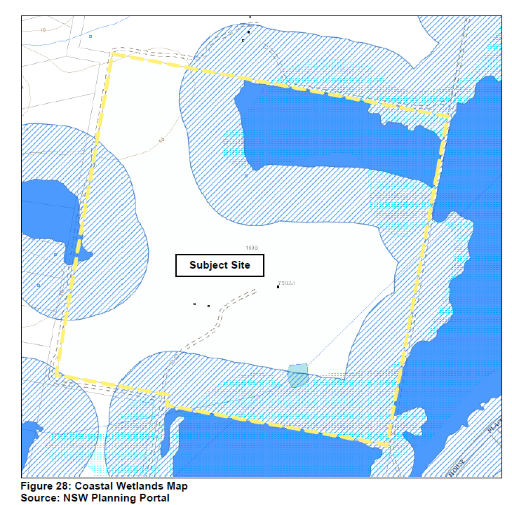

Figure 9 - Section of subdivision with works proposed in mapped coastal wetlands

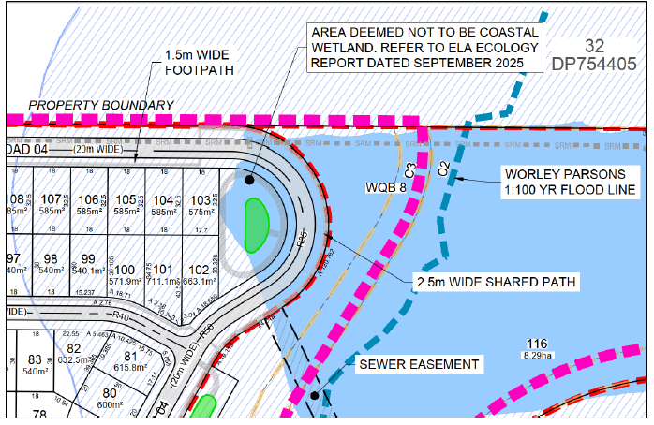

Figure 10 - Section of subdivision works with works proposed in mapped coastal wetlands

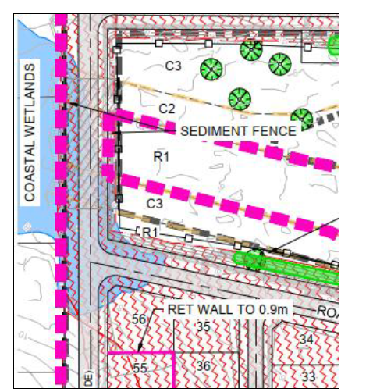

Chapter 4: Remediation of Land

The provisions of Chapter 4 have been considered in the assessment of the development application. Section 4.6 requires consent authorities to consider whether the land is contaminated, and if the land is contaminated, it is satisfied that the land is suitable in its contaminated state (or will be suitable, after remediation) for the purpose for which the development is proposed to be carried out.
The applicant has submitted details that the underlying Local Environmental Study and rezoning process included a preliminary Contaminated Land Review, dated July 2007 which considered the potential for land contamination across the Area 15 lands as a whole. This review identified one parcel as requiring further investigation due to its former orchard use. The results of that assessment are reflected in the Area 15 Area based Development Control Plan provision 370. The subject land, Lot 33 is not identified in DCP figure 252 as requiring any further contaminated land assessment.
The proposal has been reviewed by a Council Environmental Health Officer as not requiring any further investigation.
The proposal satisfies the requirements of this SEPP.

State Environmental Planning Policy (Transport and Infrastructure) 2021

The development is in proximity to electricity infrastructure and has been referred to Essential Energy in accordance with Clause 2.48. The following advice was provided from Essential Energy during assessment of the application:

Thank you for seeking comment from Essen􀆟al Energy in rela􀆟on to the proposed development at the above property.
Strictly based on the documents submitted, Essential Energy has no comments to make as to potential safety risks arising from the proposed development.

Essential Energy makes the following general comments:
- As part of the subdivision, an easement is created for any existing electrical infrastructure. The easement is to be created using Essential Energy’s standard easement terms current at the time of registration of the plan of subdivision;
- If the proposed development changes, there may be potential safety risks and it is recommended that Essential Energy is consulted for further comment;
- Any existing encumbrances in favour of Essential Energy (or its predecessors) noted on the title of the above property should be complied with;
- All Torrens lots must have access and frontage to a public road as per Service and Installation rules this is to allow for the provision of power/services to the new development, a right of carriageway can not to be used for the provision of power/services to any part of the new development.
- Council should ensure that a Notification of Arrangement (confirming satisfactory arrangements have been made for the provision of power) is issued by Essen􀆟al Energy with respect to all proposed lots which will form part of the subdivision, prior to Council releasing the Subdivision Certificate. It is the Applicant’s responsibility to make the appropriate application with Essential Energy for the supply of electricity to the subdivision, which may include the payment of fees and contributions;
- In addition, Essential Energy’s records indicate there is electricity infrastructure located within the property. Any activities within this location must be undertaken in accordance with the latest industry guideline currently known as ISSC 20 Guideline for the Management of Activities within Electricity Easements and Close to Infrastructure;
- Prior to carrying out any works, a “Dial Before You Dig” enquiry should be undertaken in accordance with the requirements of Part 5E (Protec􀆟on of Underground Electricity Power Lines) of the Electricity Supply Act 1995 (NSW);
- Given there is electricity infrastructure in the area, it is the responsibility of the person/s completing any works around powerlines to understand their safety responsibilities. SafeWork NSW (www.safework.nsw.gov.au) has publications that provide guidance when working close to electricity infrastructure. These include the Code of Practice – Work near Overhead Power Lines and Code of Practice – Work near Underground Assets.

The advice received from Essential Energy has been forwarded the applicant for consideration. A standard condition is also recommended to obtain satisfactory arrangements certification prior to issue of a Subdivision Certificate.

The development does not trigger any of the traffic generating development thresholds of Clause 2.122. Referral to the NSW Roads and Maritime Services (RMS) is not required.
Division 18 Sewerage systems. Clause 2.126 - Development permitted with or without consent. The proposal is reliant upon clause 2.126(7) which provides development for the purpose of sewage reticulation systems may be carried out with consent on any land as the proposal incorporates a sewer pipe extension that traverses part of the C2 Environmental Conservation and C3 Environmental Management zoned land under the Port Macquarie-Hastings Local Environmental Plan.
Division 20 Stormwater management systems. Clause 2.138 - Development permitted with consent. The proposal is reliant upon clause 2.138 which provides that development for the purpose of a stormwater management system may be carried out by any person with consent on any land as the proposed stormwater detention basins are located within the C3 Environmental Management zoned land under the Port Macquarie-Hastings Local Environmental Plan.
The proposal satisfies the requirements of this SEPP.
Port Macquarie-Hastings Local Environmental Plan 2011

The relevant local environmental plan applying to the site is the Port Macquarie-Hastings Local Environmental Plan 2011 (‘the LEP’). The aims of the LEP include:

(aa) to protect and promote the use and development of land for arts and cultural activity, including music and other performance arts,
(a) to protect, conserve and sustainably manage the ecological biodiversity and natural environment of the Port Macquarie-Hastings area,
(b) to facilitate a strong and diverse local economy within the Port Macquarie-Hastings area,
(c) to manage and coordinate the orderly, equitable and economic use and development of land within the Port Macquarie-Hastings area,
(d) to facilitate the provision and coordination of community services and facilities within the Port Macquarie-Hastings area,
(e) to facilitate adaptive planning for natural hazards and risks, including flooding, erosion, inundation, land stability, bush fire risk and acid sulfate soils within the Port Macquarie-Hastings area,
(f) to reinforce the role of the Port Macquarie-Hastings area’s settlement hierarchy, centred on Port Macquarie and supported by its surrounding towns and villages,
(g) to ensure the effective management of public assets within the Port Macquarie-Hastings area,
(h) to provide a land use framework for development within the Port Macquarie-Hastings area that is safe, inclusive and equitable, and caters for the housing, employment, entertainment, cultural, welfare and recreational needs of residents and visitors,
(i) to ensure that development does not conflict with the hierarchy of business and retail centres in the Port Macquarie-Hastings area and the role of the Greater Port Macquarie Central Business District as the focal point for subregional functions and service delivery,
(j) to identify and protect features of environmental, cultural or visual importance within the Port Macquarie-Hastings area,
(k) to ensure that new urban development makes a positive contribution to the public domain and streetscape,
(l) to facilitate efficient use of urban land and infrastructure by appropriate staging of development and ensuring appropriate density of development,
(m) to provide effective and efficient connectivity and movement corridors within and between subdivisions.

The proposal is consistent with these aims for the following reasons:
- The development will not result in a significant adverse impact on the ecological biodiversity and natural environment.
- The proposal appropriately responds to the natural hazards applicable to the site.
- The proposal will facilitate release of residential land and infrastructure at an appropriate density to provide for future housing opportunity.
- The proposal provides for effective connection and corridors between the adjoining subdivision.

Zoning and Permissibility (Part 2)

The site is zoned part R1 General Residential, part C2 Environmental Conservation and part C3 Environmental Management pursuant to Clause 2.2 of the LEP. Figure 9 below shows the zoning applying to the site and the submitted plans also provide a zoning overlay.

A dwelling is proposed on proposed Lot 56 which is proposed on land part zoned R1 general residential and is a permissible landuse with consent.

Figure 11 - Zoning Map (note western crown road not included in zone map area)

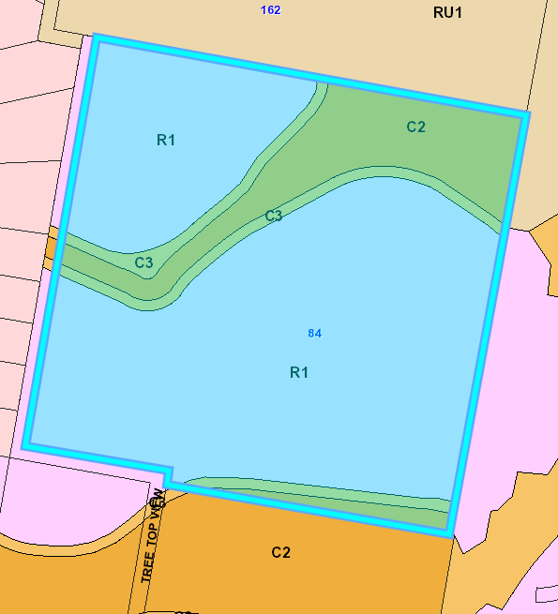

The objectives of the R1 General Residential include the following (pursuant to the Land Use Table in Clause 2.3):

  - To provide for the housing needs of the community.
  - To provide for a variety of housing types and densities.
  - To enable other land uses that provide facilities or services to meet the day to day needs of residents.

The proposal is considered to be consistent with these zone objectives for the following reason:

- The development will provide for housing needs of the community and platform for variety of housing types and densities.
- Lots proposed are for standard dwellings, though many are of ample size to accommodate a varied housing mix through dual occupancies and secondary dwellings. This allows for opportunity for a variety of housing types and densities.
- Proposed Lot 23 currently also has a proposed manufactured home estate proposed on it with subject to a separate Development Application under assessment.
- Proposed Lot 10 is noted to have the potential for a multi-dwelling housing type with its access and lot configuration.

The objectives of the C2 Environmental Conservation zone include the following (pursuant to the Land Use Table in Clause 2.3):

- To protect, manage and restore areas of high ecological, scientific, cultural or aesthetic values.
- To prevent development that could destroy, damage or otherwise have an adverse effect on those values.
- To protect coastal wetlands and littoral rainforests.
- To protect land affected by coastal processes and environmentally sensitive land.
- To prevent development that adversely affects, or would be adversely affected by, coastal processes.
- To enable development of public works and environmental facilities where such development would not have an overall detrimental impact on ecological, scientific, cultural or aesthetic values.

The objectives of the C3 zone include the following (pursuant to the Land Use Table in Clause 2.3):

- To protect, manage and restore areas with special ecological, scientific, cultural or aesthetic values.
- To provide for limited range of development that does not have adverse effect on those values.

The proposal is considered to be consistent with these zone objectives for the following reasons:

- The development footprint is primarily located outside the C2 zone. However, a sewer pipe is proposed via under bore to traverse the C2 zone which will be at a depth that will not impact any vegetation. The sewer pipeline is permissible with consent via the overriding provisions of SEPP (Transport and Infrastructure) 2021.
- The development will enhance and protect the area of the site containing high ecological value and coastal wetland.
- The main footprint of the development is located outside the E3 zone however parts of the lead in and perimeter roads, stormwater basins and sewer pipeline extension intrude which will have no adverse effect on the ecological values. Roads are permissible with consent in the C2 and C3 zone. The stormwater basins and sewer pipeline are permissible with consent via the overriding provisions of SEPP (Transport and Infrastructure) 2021.
- The development will manage and protect areas of the site containing special ecological value.
- The C2 and C3 zoned portions of the site will be appropriately managed and ultimately be dedicated to Council as envisaged in the Voluntary Planning Agreement.

Clause 2.6 - Subdivision - Consent requirements

2.6(1) provides that land to which this plan applies may be subdivided, but only with development consent. Development consent is sought under this application.

General Controls and Development Standards (Part 2, 4, 5 and 6)

The LEP also contains controls relating to development standards, miscellaneous provisions and local provisions. The controls relevant to the proposal are considered in Table 4 below.

Table 4: Consideration of the LEP Controls
Control | Requirement | Proposal | Comply
Minimum subdivision Lot size  (clause 4.1) | 450m² for R1 zone portion  40 hectares for C2 and C3 zone portions | All proposed lots within the residential zoned portion 450m² or greater in area.  The area containing the VMP plantings and water quality basins has an area of 11.8ha where a 40ha MLS applies. It is intended that this land will eventually be dedicated to Council. The proposed residue connects to a wider area, including Woodlands South. Under Section 2.75 of SEPP (Exempt and Complying Development Codes 2008, such subdivision is exempt development:  “2.75 Specified Development  The subdivision of land, for the purpose only of any one or more of the following, is development specified for this code—  (e) creating a public reserve,  (f) excising from a lot land that is, or is intended to be, used for public purposes, including drainage purposes, rural fire brigade or other emergency service purposes or public toilets.”  A Clause 4.6 variation is not needed for the proposed residue lot. | Yes  Refer to below
Height of buildings (clause 4.3) | Height of building not to exceed the maximum standard 8.5m building height. | 5.24m building height proposed. | Yes
Floor space ratio (clause 4.4 and 4.5) | Maximum floor space ratio for a building on any land is not to exceed the floor space ratio | 0.2:1 floor space ratio | Yes
Heritage conservation (clause 5.10) | Consent required for subdivision of land on which an Aboriginal place of heritage significance is located. Consider the effect of the proposed development on the heritage significance of the place. | The site is not identified as a heritage item in Schedule 5 of LEP 2011. There are no heritage items identified within the immediate vicinity of the site, the nearest items are in Kew village.  An Archaeological Investigation was prepared in support of the Area 15 Structure Plan by John Appleton dated April 2007 (Appendix M). The report found that the site does not contain artefactual material.  As part of this investigation, Trevor Roberts of the Bunyah LALC was consulted and inspected the site on 19 April 2007. No indications of site significance were identified and the Bunyah LALC advised they have no objection to development of the site subject to standard condition to cease works should artefacts be identified.  The clearing of the site was approved on this basis. | Yes
Flood Planning (clause 5.21) | Development consent must not be granted to development on land the consent authority considers to be within the flood planning area unless the consent authority is satisfied the development:  (a) is compatible with the flood function and behaviour on the land, and  (b) will not adversely affect flood behaviour in a way that results in detrimental increases in the potential flood affectation of other development or properties, and  (c) will not adversely affect the safe occupation and efficient evacuation of people or exceed the capacity of existing evacuation routes for the surrounding area in the event of a flood, and  (d) incorporates appropriate measures to manage risk to life in the event of a flood, and  (e) will not adversely affect the environment or cause avoidable erosion, siltation, destruction of riparian vegetation or a reduction in the stability of river banks or watercourses.  In deciding whether to grant development consent on land to which this clause applies, the consent authority must consider the following matters—  (a) the impact of the development on projected changes to flood behaviour as a result of climate change,  (b) the intended design and scale of buildings resulting from the development,  (c) whether the development incorporates measures to minimise the risk to life and ensure the safe evacuation of people in the event of a flood,  (d) the potential to modify, relocate or remove buildings resulting from development if the surrounding area is impacted by flooding or coastal erosion. | The site falls within mapped Flood Prone Land. The proposed fill footprints and roads align with the Area 15 Flood Study (Worley Parsons - 2011) which accompanied a rezoning/planning proposal for this area. The risk of flood impact has already been accepted and the areas of fill assessed.  Hence, proposal meets the PMHC Flood Policy requirements.  All roads are to be constructed so that the lowest point of any road is at or above FPL2 or the highest adjacent flood level as defined in Area 15 Flood Study (Worley Parsons - 2011). These requirements are recommended to ensure infrastructure is not adversely impacted by flood events and access is maintained to an acceptable standard.  To mitigate against the increased risk of construction in a flood zone, a condition has been included requiring all new works under FPL3 to be constructed of flood durable materials. | Yes
Satisfactory arrangements for State infrastructure in Urban Release Area (clause 6.1) | Development consent must not be granted for subdivision of land in an Urban Release Area unless the Director- General has certified that satisfactory arrangements have been made to contribute to the provision of designated state public infrastructure. | Satisfactory Arrangement Certification (SAC) has been provided from the Director-General for the proposed subdivision development. | Yes
Public utility infrastructure in Urban Release Area (clause 6.2) | Development consent must not be granted for development on land in an urban release area unless the Council is satisfied that any public utility infrastructure that is essential for the proposed development is available or that adequate arrangements have been made to make that infrastructure available when required. | Adequate arrangements are proposed and required for provisioning of the necessary public utility infrastructure to serve the development. Consent conditions have been recommended to re-enforce these arrangements and requirements. | Yes
Development control plan in Urban Release Area (clause 6.3) | Development consent must not be granted for development on land in an urban release area unless a development control plan that provides for the matters specified in subclause (3) has been prepared for the land. | A Development Control Plan has been developed for the land. | Yes
Acid sulfate soils (clause 7.1) | Ensure that development does not disturb, expose or drain acid sulfate soils and cause environmental damage. | The site is identified by Section 7.1 of LEP 2011 as partially affected by Class 3 and 5 acid sulfate soils. Areas of PASS are located within the low-lying C2 Environmental conservation and C3 Environmental Management zones as well as in the southeastern corner of Stage 4 in the R1 zone.  Part of Stage 4 is proposed within the Class 3 ASS in the southeast corner of the site. The Class 5 ASS are contained within the C2 and C3 zone. There are residential lots, roads, infrastructure and water quality basins proposed in Class 3 and 5 PASS. Fill is proposed in the eastern part of the site, rather than excavation which would disturb ASS.  The Coffey Geotechnics report dated 2007 identifies the ASS area as having a shallow perched groundwater table at a minimum depth of 0.48m from the surface. Excavations in this area may lower the groundwater table and require dewatering. The report recommends sheet piling or similar during construction to reduce the zone of influence. A detailed ASS management plan will be submitted at CC stage, once final design is complete for the proposed landform and infrastructure. During preparation of engineering design, further geotechnical investigations would be undertaken to address these matters. A condition of consent is anticipated in that regard.  In addition to the above, the DCP provisions for soils (Clause 369) require:  Proposed excavations in Terrain Unit C and adjoining areas are to be assessed for potential impacts on groundwater and ensure reactive and sodic soils are managed during, and post, development phases  Terrain Unit C soils are identified in the location of the proposed subdivision. During preparation of engineering design, further geotechnical investigations would be undertaken to address these matters. A condition of consent is recommended in this regard. | Yes
Essential services  (Cl 7.13) | Essential infrastructure to be provided to development | Essential services existing or proposed to be provided as detailed in the recommended conditions. Satisfactory arrangements are in place for essential services. | Yes

The proposal satisfies the requirements of this LEP.

- Section 4.15 (1)(a)(ii) - Provisions of any Proposed Instruments

There are no proposed instruments applicable to the proposal.

- Section 4.15(1)(a)(iii) - Provisions of any Development Control Plan

The following Development Control Plan is relevant to this application:

- Port Macquarie-Hastings Development Control Plan 2013 (‘the DCP’)

The key controls are discussed below and a full assessment table with consideration of applicable provisions is included in Attachment B:

- Part B - General Provisions
- Part C - Development Specific Provisions - C5 - Subdivision and C1 low density residential development
- Part D - Locality Specific Provisions - Area 15

- Section 4.15(1)(a)(iiia) – Planning agreements under Section 7.4 of the EP&A Act

The site is subject to an existing Area 15 Planning Agreement in Place (VPA) (available on Council’s website titled Area 15 Planning Agreement - Gentlemore Pty Ltd, Haloville Pty Ltd, Somersby Rural Supplies Land Holdings Pty Ltd and Somersby Rural Supplies Pty Ltd). The VPA provides for the carrying out of works for local parks, roads, sewer and water supply works, dedication of specified land to Council, dedication of Environmental Offset Land, establishment, management and dedication of environmental lands & arrangements for payment of contributions.

The Planning Agreements includes the following key provisions which have been considered as relevant to the proposed development:

- The C2 and C3 zoned land is to be managed by the proponent for 20 years under the terms of the VMP approved under DA 2017/394. Discussion has been had with proponent regarding amending the VPA to accommodate this requirement from DCCEEW. It was determined that no amendment to the VPA is required. Clauses 5 and 65 of the VPA allows further agreements between Council and Jojeni. Jojeni will manage the land for the VMP period. Upon conclusion of this period the C2 and C3 land can be dedicated to Council.
- The Environmental Offset Land Contribution (EOLC) does not apply as the Landowner is the Crighton Land Landowner (VPA Clause 29.1).
- The Federal DAWE approved VMP on Crighton (Also known as Laurieton Lifestyle VPA) land states that Environmental Management amount need not be paid and VPA should be amended accordingly.
- Separate correspondence has been provided to the proponent dated 13 December 2024, that states "Provided that the landowner meets its obligations as outlined in the VMP approved by the Commonwealth Government, the Council proposes to defer the payment of the management contribution under Clause 20 of the VPA until before the issuance of the subdivision certificate that will create the last ‘final lot’. In accordance with Clause 20.8, the management contribution would also be adjusted and reduced accordingly.

The land is subject to an Area 15 VPA referred to as (Council reference: 160.2011.00000057.001).
Previous plans submitted now superceded previously referenced ‘future connection to Botanic Drive, "connection to be constructed by Council" as per Area 15 VPA’. This statement was identified during assessment as being an incorrect assumption to detail and has been subsequently removed from the plans. The VPA only deals with Link Rd Part A and B which are both to the west of the site.
Separate correspondence issued by Council in October 2025, states that this road connection is not in Council’s Integrated Transport Plan, Delivery Program or Long Term Financial Plan. The road connection is in Council’s contributions plan which does allow for works in kind or such arrangements, but to date Council has not received a request for a works in kind agreement. It should also be noted this indicative road runs across private property and is not consistent with the right of access easement. If the proponent was to rely on this access, it is recommended that they consider a Works in Kind Agreement (WIKA) with landowner’s consent and the works are considered as part of the subject DA.
Local Park
The Subject site is identified in the VPA as land which contains a local park. As per the VPA the landowner is obligated to dedicate this land to Council and complete any relevant embellishment work before the dedication as per clause 14 of the VPA.
Figure 12 Extract from Planning Agreement showing local park provision

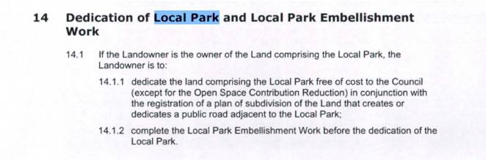
Figure 13 Extract from Planning Agreement showing local park desired location.
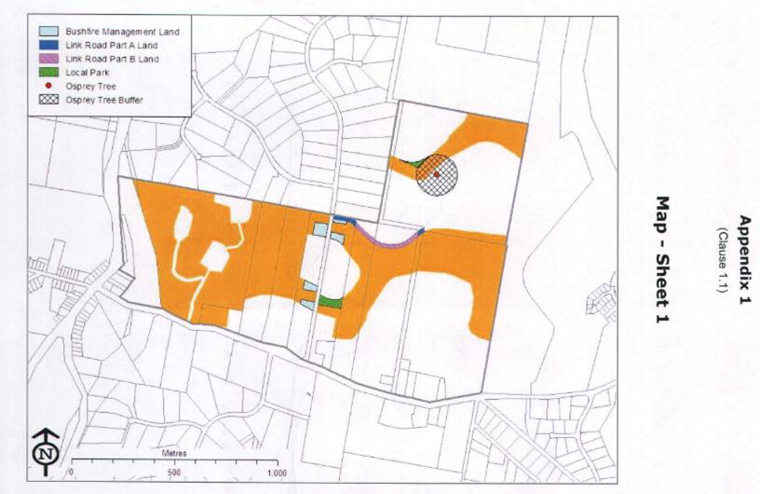

The applicant has submitted details that Figure 255 and Section 386 of the Development Control Plan show a local park on the site. The park is to have an area of 1,500m2 and be connected by pedestrian and cycle infrastructure. There are no other specifications for the park. The location of the park is within the land to be managed under the VMP by the proponent and transferred to Council when complete. There will not be any physical barrier to accessing the land for use as a park by the public.

Figure 14 Extract from DCP showing local park desired location.

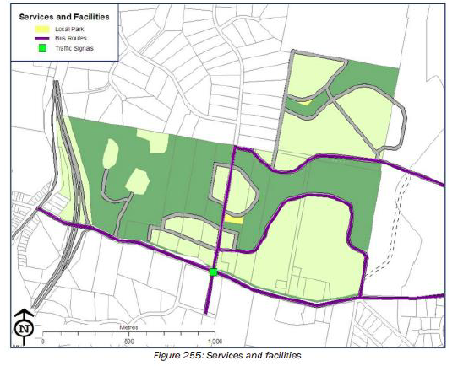

The proposal satisfies the requirements of this Planning Agreement and Deed of Variation.

An estimate of development contributions payable including Planning Agreements are attached to this report. Attachment H.

- Section 4.15(1)(a)(iv) - Provisions of Regulations

No additional matters prescribed by the regulations apply.

  - Section 4.15(1)(b) - Likely Impacts of Development

The likely impacts of that development, including environmental impacts on both the natural and built environments, and social and economic impacts in the locality must be considered. In this regard, potential impacts related to the proposal have been considered in response to SEPPs, LEP and DCP controls outlined above and the Key Issues section below.

The consideration of impacts on the natural and built environments includes the following:

- Context and Setting - The site is vacant residential and environment conversation and management zoned land and is currently under development for the purpose of the surrounding subdivision development.

The proposed development (as amended) is considered to be an appropriate response to the site’s ecological constraints and will fit satisfactorily fit into the local context.

The proposed development is considered appropriate for the site and will fit into the local context and character envisaged for the area.

- Access and traffic -

Roads
The development is proposing a new public road connection onto Lake Ridge Drive, via the creation of a new intersection and clarified during assessment as a primary road access point to service the subdivision.
During assessment the primary point of access for the subdivision was the subject of several requests for further information and amended plans together with identifying the status of the adjoining western subdivision at No. 13 Tree Top View which includes an approved road access connection to Lake Ridge Drive. This development was identified as being physically commenced during assessment. Additional supporting justification has been provided from the applicant to support the status of this road connection and advice obtained on the alternate Botanic Drive east option.
To achieve this, a new road corridor will be constructed across three properties to the south and west of the development site. The location of the proposed road corridor is consistent with the route outlined in Figure 246: Area 15 Camden Haven Structure Plan of the current DCP.
The development consists of 10 new roads, including 5 x Collector Roads (Roads 1, 2, 3, 4 and 5), 1 x Access Place (Road 6) and 3 x Local Streets (Roads 7, 8 and 9). Road 10 constitutes an alternative emergency access route, along the public road corridor connecting Tree Top View to Ocean Drive in the south. The main Collector Road (Road 1) will ultimately connect onto Lake Ride Drive in the west, via the new intersection. This intersection and all new roads within the proposed development have been conditioned to meet Auspec Geometric Road Design and Bushfire standards. In accordance with these standards, the carriageway width of each Collector Road will be have a minimum 7m wide carriageway, within a 20m wide road reserve. Similarly, each Access Place and Local Road shall be a minimum 7m wide, within a 15m wide road reserve. SE (layback) kerb and gutter is proposed along all road frontages, except for some sections of the Collector Roads, where SA (up-right) kerb and gutter may be installed. The proposed internal road network complies with the minimum requirements of the DCP and is consistent with other road cross sections within the Area 15 - Camden Haven precinct.
The Area 15 roads strategy and DCP 2013 provides for a partially funded road link west to Lake Ridge Drive, with the relevant road segments to be constructed by the respective landowners. The DCP 2013 also provides for a collector road link from the southeast corner of Woodlands North to Botanic Drive to be constructed and fully funded by Council, with no provision made in the VPA for its funding by the Applicant. The submitted plans provide for a future connection from the site to Botanic Drive.

Traffic and Transport
The site is approved for residential subdivision under the current DCP. The new intersection on Lake Ridge Drive will be designed in accordance with Auspec and Austroads standards and conditions have been recommended to reflect these requirements. A traffic impact assessment was undertaken by Positive Traffic (Report No. PT23068r01_Final_V7, dated: December 2025), in which the surrounding road network was assessed as being adequate to accommodate the likely additional traffic generation associated with this development. The report demonstrated that the existing intersections surrounding the development would continue to operate at satisfactory levels of service following full development of the site, looking over a 10 year projection period. This includes the key intersection of Lake Ridge Drive / Ocean Dive, which services the development. The eventual upgrade of the Lake Ridge Drive / Ocean Drive intersection to traffic signals (traffic lights) as required under the current DCP, will be undertaken as future development continues to occur in the area, and will be paid for via development contributions as specified in the existing voluntary planning agreement (VPA).
Site Frontage & Access
Each residential, torrens title lot created in this development will have sufficient frontage to allow for an individual driveway. To encourage pedestrian access, footpath is proposed along one side of each Local road and Access place. As the Area 15 precinct continues to develop, it is anticipated that this new foot-paving will eventually connect onto the existing footpath and cycleway network within the Kew / Lakewood area. For bushfire purposes, an alternative emergency access is also proposed down the existing public road known as “Tree Top View,” which connects onto Ocean Drive. Access shall comply with Council AUSPEC and Australian Standards, and conditions have been recommended to reflect these requirements.
- Public Domain - The development proposes construction of a public road network and pedestrian linkages as envisaged in the provisions of Port Macquarie Hastings Development Control Plan 2013.

- Water Supply Connection - Water supply arrangements including service alignments were the subject of RFIs during assessment and plan amendments. The following commentary is to be taken into account during the assessment for DA purposes and will be reviewed and worked through prior to the issuing of a S306 Notice of Requirements and/or Letter of Acceptance under the Water Management Act.

Prior to the issue of any Section 307 Certificate of Compliance under the Water Management Act, a minimum of two potable water supply feeds are required to service the proposed subdivision. One feed is to be provided via connection to the existing 250 mm water main on Botanic Drive, or an alternative arrangement as approved by the Community Utilities Design and Development Manager following assessment through hydraulic modelling.

Hydraulic modelling is required to define project staging in accordance with the adopted water supply demand strategy and to identify all associated infrastructure works, including any required augmentation. The modelling must be undertaken by a suitably qualified Hydraulic Engineer using acceptable inputs and software compatible with, and approved by, Council. The resulting water servicing strategy must incorporate current water infrastructure design standards and demonstrate compliance with required water quality (including water age), supply, and firefighting pressure criteria for both the development and the surrounding network.

The proposed water main connection to Botanic Drive is subject to separate environmental approval.

Staging of water main works is to be confirmed as part of the Section 306 Notice of Requirements under the Water Management Act. Hydraulic modelling will be required to determine the staging necessary to service the subdivision and to support future operation and maintenance of Council’s network, including consideration of network looping, dead-end minimisation, and water quality outcomes. Whereby termination points or dead-ends are avoided to minimise the likelihood of poor water quality and customer complaints. Any deviation from the original water servicing strategy, including provision of a secondary connection to Botanic Drive, may necessitate downsizing of the existing 250mm PVC water main on Botanic Drive to mitigate potential water quality issues.

An interconnection is also required to support the recycled water network. The potable water network modelling must account for this requirement.

Conditions of consent have been recommended to obtain a section 306 and 307 certificates of compliance to ensure compliance with the requirements under the Water Management Act 2000.

- Sewer Connection - The site has access arrangements that can be made for sewer infrastructure and is capable of being connected to the existing network. Appropriate conditions of consent have been applied to obtain a section 306 and 307 certificates of compliance to ensure compliance with the requirements under the Water Management Act 2000.

- Stormwater - The site naturally grades natural watercourse that traverses through the development lot and is currently (un)serviced.

The legal point of discharge for the proposed development is defined as end of line treatments discharging appropriately to natural water course/s, within the development property. These end of line systems will need to be constructed as part of the subdivision.
Stormwater from the proposed development is planned to be disposed via end of line biofiltration water quality basins that ultimately discharge to the natural watercourses / gullies / low points, which is consistent with the above requirements.
Additional information was requested and addressed via amendments to the subdivision plans during assessment including addressing but not limited to:
- Stormwater quality infrastructure differing from DCP Area 15 Precinct Stormwater Management Plan 2010. MUSIC modelling was requested to demonstrate proposed water quality basins will meet (or improve) DCP water quality reductions. DCP proposed water quality controls referred to.
- Details on stormwater plans for basin / water quality type to better clarify what type of basins are proposed. Catchment plan requested to demonstrate each sub catchment for proposed stormwater infrastructure and inline with MUSIC modelling catchments.
- Sufficient space to provide an all access track surrounding basins to allow unimpeded maintenance access.
- Confirm the proposed development type/ use intended for stage 2 area (Proposed lot 49) as there are two proposed basins to treat this large lot, which appear to be intended for Council ownership. Private owned and maintained water quality controls shall be provided within any future proposed lots to be MHE or similar including private internal roads.
- The upstream catchment of the development site (western boundary) is considerably large, which also contains a piped culvert system beneath Lake Ridge Drive that flows into the development site. Plans currently do not provide any detail how this upper catchment will be managed beneath the proposed road along western boundary. Provide suitable infrastructure and indicative sizing to meet AUSPEC D5 whilst ensuring no upstream afflux from local catchment storm flows.
- Provide indicative road and verge levels for western boundary to demonstrate how natural runoff from existing private properties is managed i.e. 6 to 16 Lake Ridge Drive, will these upstream catchments flow via proposed stormwater quality systems.
- Confirm the protection measures and overland flow management for the large section of proposed Lot 49 that grades towards proposed lots 16 to 48. It is noted between Lot 33 and 34 a drainage line is shown on plan, however the upstream area is large and assumed to be directed between Lot 33 and 34. Please confirm the interim protection measures and overland flow paths / piped systems will be sufficient not to inundate proposed stage 1 lots and associated road / stormwater infrastructure.
Following the above and additional information submitted it is recommended that a detailed site stormwater management plan will be required to be submitted for assessment with the Section 68 application and prior to the issue of a Subdivision Works Certificate.
In accordance with Councils AUSPEC requirements, the following must be incorporated into the stormwater drainage plan:
- Water quality controls treating residential lots and public road areas demonstrating total site water quality targets are met in accordance with AUSPEC D7 requirements.
- Demonstrate via hydrological modelling and MUSIC modelling how public stormwater systems can manage upstream catchment areas to the west of the development site / road 3. Any proposed swales / cut off drains outside of the development lot will require owners consent permitting construction and updating of 88b instruments requiring such drains to define extents and ensure they remain in perpetuity.
- Demonstrate maintenance access to proposed public biofiltration basins.
- Provide hydraulic modelling showing no afflux / increase to localised catchment flow levels within upstream private properties due to proposed road 3 and associated culvert infrastructure.

Appropriate conditions are recommended in this regard.

- Utilities – Telecommunication and electricity services are available to the site. Evidence of satisfactory arrangements with the relevant utility authorities for provision of services to the development will be required prior to works commencing.

- Heritage – Refer to comments under clause 5.10 of the Port Macquarie-Hastings Local Environmental Plan 2011 within this report. No adverse impacts are anticipated.

- Other land resources – The proposed development is located within residential zoned land envisaged for future urban development and will not sterilise any significant mineral or agricultural resource.

- Water Cycle - The proposed development will not have any significant adverse impacts on water resources and the water cycle.

- Soils - The proposed development will not have any significant adverse impacts on soils in terms of quality, erosion, stability and/or productivity. A consent condition has been recommended requiring a detailed soil and water management plan be approved before commencement of any clearing or earthworks. Subject to the implementation of this plan (including erosion and sediment control measures) prior to and during construction no adverse impact are anticipated. Temporary stockpiles are proposed as added to the application. Satisfactory mitigation measures have been proposed to management soil erosion and sediment control in this regard as shown on the plans.

- Air and Microclimate - The construction and operation of the proposed development will not result in any significant adverse impacts on the existing air quality or result in any pollution. Standard precautionary site and dust management condition recommended.

- Flora and Fauna impacts - A Flora and Fauna Assessment report prepared by Ecological Australia dated 12 September 2025 has been submitted. Additional information and amended plans have been submitted during assessment to address assessment concerns raised.

The following assessment comments are provided in regards to flora and fauna impacts:

- The proposed development footprint was primarily composed of cleared land covered in chipped vegetation with some regeneration of native vegetation. The cleared area was consistent with the area previously cleared as part of DA 2017/394. Some areas of the development footprint contained remnant native vegetation.
- The Flora and Fauna Assessment Report included an assessment for impacts to Wallum Froglet but found that none were recorded within the proposed development footprint. The Test of Significance was undertaken as records are close to the site and suitable habitat is identified on the Lot. No significant impact was identified.
- A first and second order stream run through the south east corner of the subject land, with the second order stream present in the development footprint. There is a small portion of the first order stream present in the development footprint, however a majority is within the VMP area (Figure 6). Works proposed on waterfront land (within 40 m of the stream) require an application to be submitted and obtained for a controlled activity approval from the Department of Climate Change, Energy, the Environment and Water - Water Group.
- The revised plans have relocated 6 of the eight proposed sediment basins to already cleared R1 zoned land, removing them from mapped Coastal Wetlands. 2 basins remain in the southern C3-zoned area however this location was approved for clearing under DA2017-394 and the location is consistent with what is shown under the Development Control Plan for Area 15.
- All proposed works within Lot 33 DP754405 appear confined to areas previously approved and cleared under DA2017-394, including mapped Coastal Wetlands.
- The additional information prepared by Greenloaning Biostudies Pty Ltd dated 25/09/2025 and addendum prepared by Greenloaning Biostudies Pty Ltd dated 17/12/2025 regarding Coastal Wetland Mapping on Lot 33 DP754405 has been considered shown as Areas 1, 2 and 3 in the report. These locations were included in the DA2017-394.
- Given the proposed development within Lot 33 DP754405 is limited to areas cleared under DA2017-394, and with the additional information provided, it is considered that appropriate measures have been or will be implemented to protect and enhance the wetland’s biophysical, hydrological, and ecological values within Lot 33 DP754405.
- Road access is proposed via adjacent lot under DA2017/1059 consent to the west (see approved plans D2024/011254)
- Future road access is also proposed via Voluntary Planning Agreement connecting to Botanic Drive as shown in the DCP but this is not part of this DA. Council has no plans to construct the road currently and could be indicatively within the next 4 - 8 years (See correspondence D2025/492115).
- SEPP (Biodiversity Conservation) 2021 Chapter 4 applies to the proposed development because LOT: 33 DP: 754405 is over 1ha and there is no approved KPoM.
- For this development Sec 4.9 (5b) of SEPP (Biodiversity Conservation) 2021 applies. Because the area is cleared already under clearing under DA2017-394 no further considerations are required.

Appropriate conditions are recommended to address tree retention, tree protection fencing, and aborist treatment to any trees damaged during construction.

- Waste – Disposal of cleared vegetation shall be disposed of via mulching and/or approved waste management facility and shall not be burned onsite. A condition is recommended to confirm no burning of felled vegetation occur onsite.

- Noise and vibration – Construction noise impacts can be managed by restricting work to the standard construction hours, as recommended in the consent conditions.

- Bushfire – The site is mapped as bushfire prone land.

The application originally included a Bush Fire Assessment Report prepared by David Pensini Building Certification and Environmental services. In accordance with Section 100B - Rural Fires Act 1997 - the application proposes subdivision of bush fire prone land that could lawfully be used for residential purposes. As a result, the application and report was forwarded to the NSW Rural Fire Service who initially issued a Bushfire Safety Authority subject to consent conditions.

One of the consent conditions was identified during assessment to require the following which was considered impractical for consideration of the development (extract from BFSA 5 June 2025):

The applicant was subsequently recommended to reconsider their proposal and provide additional specialist details and an amended subdivision plan in consultation with the NSW Rural Fire Service. The amended subdivision plan also includes an alternative emergency access road heading south from the subdivision along the recently dedicated public road from Crown Roads status. An amended Bushfire Safety Authority was obtained which is recommended to be complied with via a recommended consent condition.

- Flooding - Part of site subject to flooding extract from plans.

A Flood Impact Assessment was prepared for Area 15 by Worley Parsons. The study identifies a flood hazard on the site, which is contained within the C2 and C3 zone. The proposed water quality basins and perimeter road will contain the 1 in 100 flood level within the existing wetlands and mitigate the flood hazard.

All roads are to be constructed so that the lowest point of any road is at or above FPL2 or the highest adjacent flood level as defined in Area 15 Flood Study (Worley Parsons - 2011). These requirements are recommended to ensure infrastructure is not adversely impacted by flood events and access is maintained to an acceptable standard.
To mitigate against the increased risk of construction in a flood zone, a condition has been included requiring all new works under FPL3 to be constructed of flood durable materials.

The flood impact and risk assessment has been reviewed by Council’s specialist flood officer who gave consideration to the objectives of Clause 5.21 of the LEP, Council’s Flood Policy 2018, the NSW Government’s Considering Flooding in Land Use Planning Guideline 2021 and the NSW Government’s Floodplain Development Manual (2005).

It is considered that:
- The proposal is sufficiently compatible with the flood function and behaviour on the land.
- The proposal will not result in any significant adverse effects on flood behaviour that would result in detrimental increases in the potential flood affectation of other development or properties.
- The proposal will not result in any adverse effects on the safe occupation and efficient evacuation of people along existing evacuation routes for the surrounding area.
- The proposal incorporates sufficient measures to minimise and manage the flood risk to life and property associated with the use of land.
- The proposal is not likely to significantly adversely affect the environment or cause avoidable erosion, siltation, destruction of riparian vegetation or a reduction in the stability of river banks or watercourses.
- The proposal is not likely to result in unsustainable social and economic costs to the community as a consequence of flooding.
- The proposal will not result in any identifiable adverse impacts to flood behaviour as a result of projected climate change.
Appropriate consent conditions have been recommended including certification of minimum finished road and lot levels having regard to Council’s Flood Policy.

- Safety, security and crime prevention – The proposed development will be unlikely to create any concealment/entrapment areas or crime spots that would result in any identifiable loss of safety or reduction of security in the immediate area.

- Social impact – Given the nature of the proposed development and its location the proposal is not considered to have any significant adverse social impacts. The use will provide for further interaction between members of the community and provide for future housing needs.

- Economic impact – The proposal is not considered to have any significant adverse economic impacts on the locality. A likely positive impact is that the development will maintain employment in the construction industry, which will lead to flow impacts such as expenditure in the area.

- Site design and internal design – The proposed development design has had regard important environmental constraints and satisfactorily responds to the site attributes and will fit into the locality. No adverse impacts likely.

- Construction – Construction impacts are considered capable of being managed, standard construction and site management conditions have been recommended.

- Cumulative impacts – The proposed development is consistent with the relevant planning controls and is not considered to have any significant adverse cumulative impacts on the natural or built environment or the social and economic attributes of the locality. The cumulative impacts of clearing, construction and operation of the subject site and surrounding sites was also considered in the underlying strategic planning preparation of the Area 15 LES and rezoning.

Accordingly, it is considered that the proposal will not result in any significant adverse impacts in the locality as outlined above.

  - Section 4.15(1)(c) - Suitability of the site

The proposed development and subdivision layout (as amended) are considered to be an appropriate response to the ecological, bushfire and flooding constraints that exist within and around the site. The proposed development will fit into the locality and is consistent with that envisaged in the adopted area-based planning controls for the site.

  - Section 4.15(1)(d) - Public Submissions

1 submission has been received during assessment from a neighbouring property owner.

Key issues raised as summarised relate to:
- Link roads and Area 15 Voluntary Planning Agreement - Link Roads A and B.; and
- Relationship to neighbouring approved subdivision DA2017 - 1059.

The issues raised have been forwarded to the applicant for consideration during assessment and considered in the assessment of the application. Comments in response to the issues raised are provided below:

- DA 2017 - 1059 and its approved road access connection to the west is proposed to be utilised for access to the subdivision. This DA has physically commenced during assessment and is considered an appropriate planning outcome to rely upon a primary access in difference to the original application proposing access as a ‘future road connection’ only.

  - Section 4.15(1)(e) - Public interest

The proposed development satisfies relevant planning controls and will not have any significant adverse impacts on the wider public interest. The provision of appropriately located housing opportunities is considered to be in the public interest, as is a subdivision design and single dwelling that adequately responds to the relevant constraints affecting the land. These outcomes are considered to have been achieved by the proposal.

Ecologically Sustainable Development and Precautionary Principle

Ecologically sustainable development requires the effective integration of economic and environmental considerations in decision-making processes.

The four principles of ecologically sustainable development are:
- the precautionary principle,
- intergenerational equity,
- conservation of biological diversity and ecological integrity,
- improved valuation, pricing and incentive mechanisms.
The principles of ESD require that a balance needs to be struck between the manmade development and the environmental impacts. Based on the assessment provided in the report and with recommended conditions of consent, it is considered an appropriate balance has been struck.

Climate change

The proposal is not considered to be vulnerable to any risks associated with climate
change.

- REFERRALS AND SUBMISSIONS

  - Agency Referrals and Concurrence

The development application has been referred to various agencies for comment/concurrence/referral as required by the EP&A Act and outlined below in Table 5.

There are no outstanding issues arising from these concurrence and referral requirements subject to the imposition of the recommended conditions of consent being imposed.

Table 5: Concurrence and Referrals to agencies
Agency | Concurrence/  referral trigger | Comments  (Issue, resolution, conditions) | Resolved
Concurrence Requirements (s4.13 of EP&A Act)
N/A
Referral/Consultation Agencies
Essential Energy | Section 2.48 of State Environmental Planning Policy (Transport and Infrastructure) 2021 | No concerns or safety risks identified. | Y
Integrated Development (S 4.46 of the EP&A Act)
NSW Rural Fire Service | S100B - Rural Fires Act 1997  bush fire safety for subdivision of land that could lawfully be used for residential purposes. | Bushfire safety authority received with number of conditions which form part of the recommended consent conditions. | Y
NSW Department of Climate Change, Energy, the Environment and Water - Water Group | S91 - Water Management Act 2000 works within 40m of natural waterbody. | General Terms of Approval (GTAs) issued which form part of the recommended consent conditions. | Y
NSW Department of Planning, Housing and Infrastructure | C6.1 Port Macquarie-Hastings Local Environmental Plan 2011 - Satisfactory arrangements for designated State public infrastructure | No conditions recommended. | Y

  - Council Officer Referrals

The development application has been referred to various Council officers for technical review as outlined Table 6.

Table 6: Consideration of Council Referrals
Officer | Comments | Resolved
Stormwater engineer | The stormwater details and amended plans submitted during assessment have been reviewed and addressed earlier in this report. Conditions recommended. | Yes
Development Engineer | The traffic and road details and amended plans submitted during assessment have been reviewed and addressed earlier in this report. Conditions recommended. | Yes
Ecologist | The ecological details and amended plans submitted during assessment have been reviewed and addressed earlier in this report. Conditions recommended. | Yes
Water and Sewer | Water and sewer infrastructure is available and the development is capable of being connected.  Council’s Water and Sewer Team have reviewed the proposal and issued a section 306 Notice of Requirements confirming servicing arrangements. Standard conditions of consent have been applied to obtain a section 307 certificate of compliance to ensure compliance with the requirements under the Water Management Act 2000. | Yes
Flooding | The submitted flood impact assessment report has been reviewed by Councils flooding officer and appropriate consent conditions recommended to confirm the finished road and lot levels meet the requirements of Council’s Flood Policy. | Yes
Environmental Health | Appropriate consent conditions have been recommended to ensure the mitigation measures are implemented. | Yes
Development Contributions | Development contributions and obligations under the applicable Voluntary Planning Agreements (VPAs) apply. Consent conditions have been recommended requiring payment of development contributions and fulfilment of VPA obligations. | Yes

  - Community Consultation

The proposal was notified in accordance with the Council’s Community Participation Plan from 6 March to 4 April 2025. The notification included the following:

- Notification letters sent to adjoining and adjacent properties; and
- Advertising on the Council’s website; and
- Placement of Designated Development sign onsite.

The Council received 1 submission during the exhibition period and has received no further submissions up until the date of this report.

- KEY ISSUES
The following key issues are relevant to the assessment of this application having considered the relevant planning controls and the proposal in detail through this report:

- 1 submission received
- Impacts to mapped coastal wetlands
- Management of environmental lands
- Road access
- Ecology
- Stormwater management
- Traffic impacts
- Bushfire risk management
- Flooding impacts

- CONCLUSION

This development application has been considered in accordance with the requirements of the EP&A Act and the Regulations as outlined in this report. Following a thorough assessment of the relevant planning controls, issues raised in submissions and the key issues identified in this report, it is considered that the application can be supported.

Overall, the site is considered suitable for the proposed development and the proposal adequately addresses relevant planning controls. The development is not considered to be contrary to the public's interest and will not result a significant adverse social, environmental or economic impact.

It is considered that the key issues as outlined in Section 5 have been resolved satisfactorily through amendments to the proposal and/or in the recommended draft conditions at Attachment A.

- RECOMMENDATION

That the Development Application DA2025 - 97 (PPSNTH-410) for a Staged 115 Lot Residential Subdivision and Associated Infrastructure, and 1 dwelling (proposed Lot 56) be APPROVED pursuant to Section 4.16(1)(a) of the Environmental Planning and Assessment Act 1979 subject to the draft conditions of consent attached to this report at Attachment A.

The following attachments are provided:

- Attachment A: Draft Conditions of Consent
- Attachment B: Development Control Plan 2013 assessment tables
- Attachment C: Subdivision Plans
- Attachment D: Lot 56 Dwelling plans
- Attachment E: NSW RFS Bushfire Safety Authority conditions
- Attachment F: NSW Department of Climate Change, Energy, the Environment and Water - Water Group - General Terms of Approval
- Attachment G: Area 15 Planning Agreement
- Attachment H: Contribution Estimates
- Attachment I: Hones Lawyers Road link opinion

